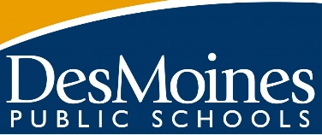

Dear 21st Century Family,
We will be offering another session of our 21st Century programming to students this winter. The dates of this program will be January 4th-March 12th. 21st Century (21CCLC) is FREE programming for elementary students; club offerings include things like magic club, art club, 4-H, and more! These clubs are interactive and hands-on.
When school is in HYBRID, students will stay after school for their clubs on their in-person learning days. For Example: If your student is in the Monday/Tuesday Cohort- they would stay afterschool until 5:30pm on Monday, Tuesday and every other Wednesday. On their virtual learning Wednesday (every other Wednesday), they will do their club from home. The same is true if they are in the Thursday/Friday cohort.
If school is 100% virtual, students will STILL participate in their clubs online through “Teams” as they would for school. Students will be provided a supply bag to do their clubs at home so they can continue with the hands-on projects.
We would like to invite your child(ren) to participate in this amazing opportunity!
We have a limited number of spots, to register your student please contact me at: Dema Abuassaf. dema.abuassaf@dmschools.org
Thank you!

