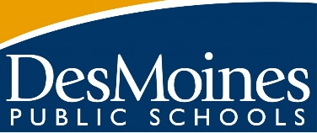

Dear 21st Century Family,
We will be offering another session of our 21st Century programming to students this winter. The dates of this program will be January 4th-March 12th. 21st Century (21CCLC) is FREE programming for elementary students; club offerings include things like magic club, art club, 4-H, and more! These clubs are interactive and hands-on.
We want to extend an invitation to participate in these clubs to students who are 100% virtual OR would prefer to do these clubs from home. Students would access these clubs online, through TEAMS, as they do for school. Each club will be on a certain day and a certain time (between 2:30p-5:30p). Students will be given a supply kit so they can participate in all the hands-on activities. 21st Century staff will also check in with the students weekly to ensure they have all they need for their clubs!
To register your student please contact me at: Dema Abuassaf ( dema.abuassaf@dmschools.org)

